Meshaal Mouawad
Mississippi State University, Electrical and Computer Engineering Department,
This is a summary report of my research assignments I was given by my advisor during my PhD program
Summary Report: week 17
For Research Assignments of my PhD

July 19, 2021

The instructions in this report as the followings:
(1) get the Node distance matrix through VD;
(2) get the Target distance matrix for TSP. (Two ways to get the two target distance. 1) connect the current target direct to the nearest node from VD toward the next target (shorter path) 2) Connect the current target point vertically to the nearest edge (safe path) ):

(3) input the goals to the DWA and get the final result
(1 liked)
Edited

Voronoi Diagram, TSP, and DWA Stages

- Environmental Exploration: to avoid the obstacles and set the global path, we have constructed the Voronoi Diagram. And then we pick some local points $P_{n}$ such that $P_{1}, P_{2}, P_{3}…P_{n}$is a target local points on the Voronoi Diagram.
the points are:
Data from the TSP Window
----------data--------------
local_locations x y
0 p_n1 35 33
1 p_n2 258 73
2 p_n3 257 230
3 p_n4 428 307
-----------------------------

 | X | Y
$$p_{1}$$ | 11 | 5 | [35 33]
$$p_{2}$$ | 57 | 13 | [258 73]
$$p_{3}$$ | 34.8 | 20.44 | [257 230]
$$p_{4}$$ | 6.41 | 24.49 | [428 307]
$$p_{5}$$ | 6.81 | 78.97
$$p_{6}$$ | 39.47 | 85.38
$$p_{7}$$ | 67.33 | 69.95
$$p_{8}$$ | 29.45 | 51.11
$$p_{9}$$ | 25.49 | 39.88
$$p_{10}$$ | 57.91 | 52.51
$$p_{11}$$ | 89.93 | 42.8
$$p_{12}$$ | 94.18 | 22.64
$$p_{13}$$ | 89.17 | 69.55

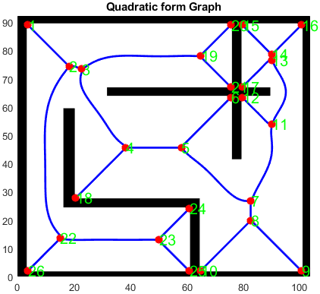

- Multi-goal path planning: We then find the shortest path between the local points $P_{n}$ which we used TSP (Travelling salesman problem) algorithms. is applied to connect some goals/waypoints that we need to explore, rescue, and reach.

We used CBC MILP Solver for optimization. The output for the optimal path is:
[(0, 1), (1, 3), (2, 0), (3, 2)]

The solution visualization is:
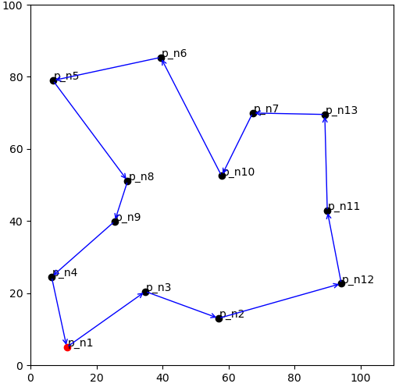

​

- Local navigator using DWA (Dynamic Window Approach): ) method to walk a mobile robot from starting point to goal along the edges of built GVD. DWA to navigate the robot to connect multiple goals depicted by the green stars.

After that, the next step will be the Mapping

Conclusion

VD
Generate VD
TSP:
to connect multiple points, and minimize traveling distant.

DWA:
Path planning and local navigation. To walk the robot from start point to the goal along the edge of GVD.

Mapping:

Python
Output

